Order Of Service

Singing: Psalm 119c—CW page 111

Reading: Psalm 55

Opening Hymn: TLH 227

Reading: Acts 5:17-26

Request Hymn: CW Supplement 702

Reading: John 12:44-50

Sermon Hymn: TLH 236

Sermon Text: Song Of Solomon 8:6

Most Vehement Flame

Prayer

The Apostles’ Creed, TLH page 12

Holy Communion

The Lord's Prayer

The Blessing

Closing Hymn: TLH 46

* * * * * * * * * * *

Bible Study: Lambs: Woodchuck
Sheep: Romans 4:13-25
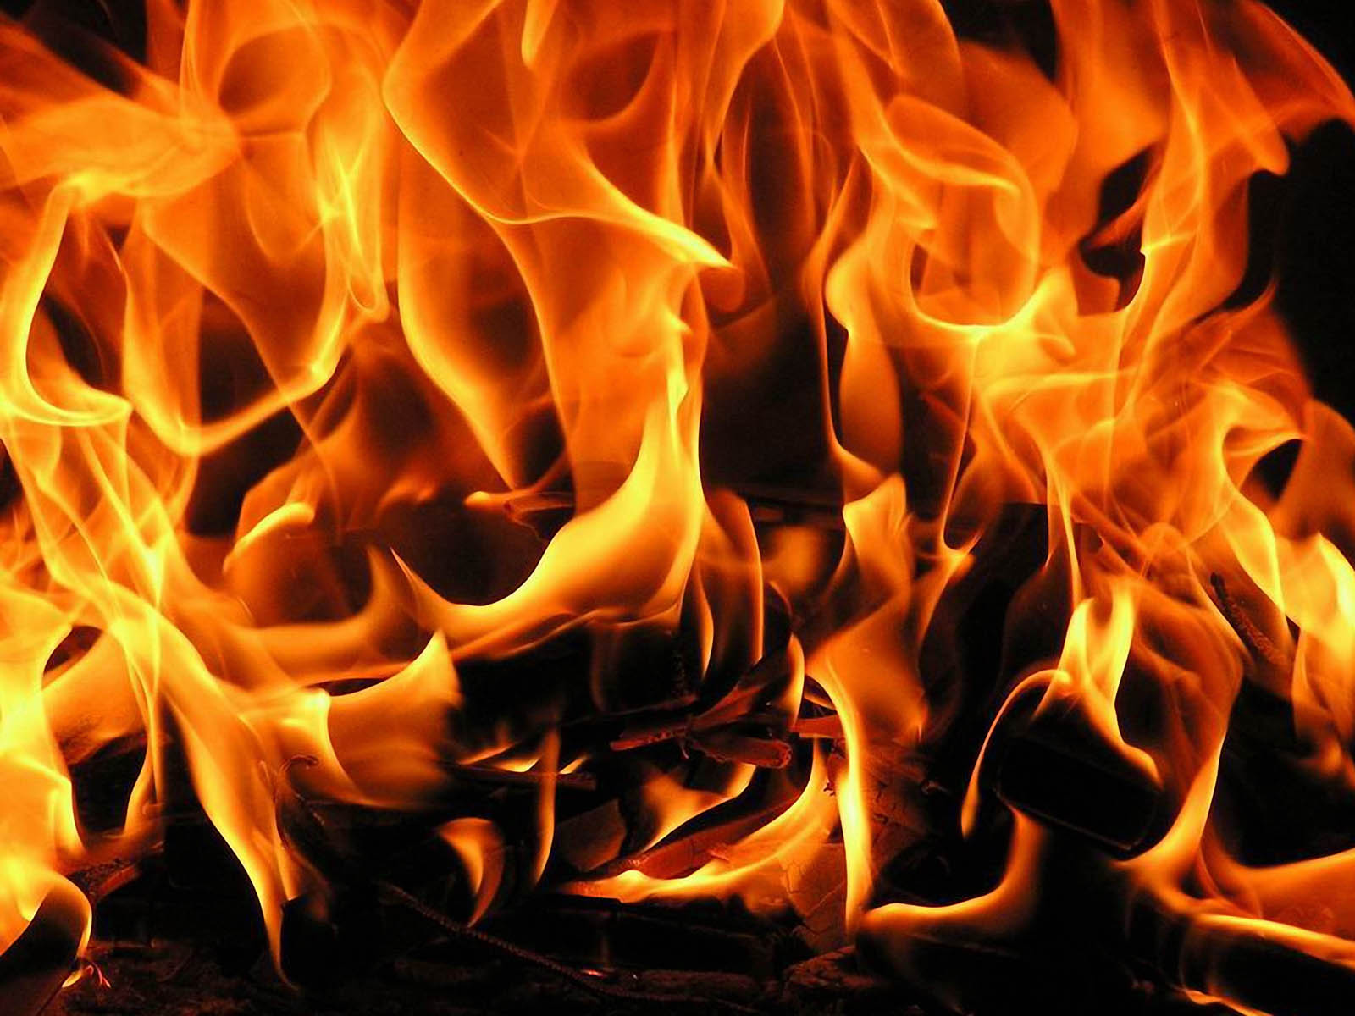

Most Vehement Flame

Water
Of
Life

24 September 2017

W A T E R O F L I F E

Independent Christian Church—Conservative Lutheran Doctrine

Worship Service: 9:30 a.m. Bible Study: 10:45 a.m.

Larry Cooper, Pastor E-Mail address:
111 N. Ridge Road lcooper@wateroflife.cc
Coon Valley, WI 54623 Web Site:
Phone: (608) 452-2105 www.wateroflife.cc

* * * * * * * * * * * * * * * * * * * * * * * * * * *

Sermon Text: Song Of Solomon 8:6

Most Vehement Flame

* * * * * * * * * * * * * * * * * * * * * * * * * * *

Song of Solomon 8:6 Set me as a seal upon thine heart, as a seal upon thine arm: for love is strong as death; jealousy is cruel as the grave: the coals thereof are coals of fire, which hath a most vehement flame.

Related Passages:

Exodus 3:1-6

1 Now Moses kept the flock of Jethro his father in law, the priest of Midian: and he led the flock to the backside of the desert, and came to the mountain of God, even to Horeb.
2 And the angel of the LORD appeared unto him in a flame of fire out of the midst of a bush: and he looked, and, behold, the bush burned with fire, and the bush was not consumed.
3 And Moses said, I will now turn aside, and see this great sight, why the bush is not burnt.
4 And when the LORD saw that he turned aside to see, God called unto him out of the midst of the bush, and said, Moses, Moses. And he said, Here am I.
5 And he said, Draw not nigh hither: put off thy shoes from off thy feet, for the place whereon thou standest is holy ground.
6 Moreover he said, I am the God of thy father, the God of Abraham, the God of Isaac, and the God of Jacob. And Moses hid his face; for he was afraid to look upon God.

Daniel 3:23-25

23 And these three men, Shadrach, Meshach, and Abednego, fell down bound into the midst of the burning fiery furnace.
24 Then Nebuchadnezzar the king was astonied, and rose up in haste, and spake, and said unto his counsellors, Did not we cast three men bound into the midst of the fire? They answered and said unto the king, True, O king.
25 He answered and said, Lo, I see four men loose, walking in the midst of the fire, and they have no hurt; and the form of the fourth is like the Son of God.

Hebrews 12:28-29

28 Wherefore we receiving a kingdom which cannot be moved, let us have grace, whereby we may serve God acceptably with reverence and godly fear:
29 For our God is a consuming fire.

